**Sprint 1 Plan**

Atheneum

4/20/16

Completion date: 5/5/16

Goals: Create a rough draft website with upload/download functionality and a working backend.

**User Story 1:** As a user I want to be able to upload and download documents through a web interface to be able to more readily access information

Task 1: Web interface for upload/download -- 6 pts

Task 2: Create database -- 5

Task 3: Framework (explore options, W2P vs NJS) -- 8

**Total time for User Story 1:** 19 hours

**Backlog:** (optional)

Task 4: Ethereum Node -- 3 (low prio)

Task 5: Smart Contract -- 3 (low prio)

**Team Roles:**

Edwin Ramirez: PO, developer

Seth Little: Developer

Ian Hardy: Scrum master (Sprint 1), Developer

Cole Boyer Developer

Nikola Panayotov: Developer

**Initial Task Assignments:**

Edwin Ramirez: Research/ hack out NJS/Firebase options (Task 2, 3)

Seth Little: Design W2P framework, help with web frontend (Task 1, 2, 3)

Ian Hardy: Website structure/ design layout (HTML, CSS) (Task 1, look forward into backlog)

Cole Boyer: Frontend (HTML/CSS) (Task 1, look forward into backlog)

Nikola Panayotov: Interface between framework options, help determine best option for

ethereum integration (Task 3)

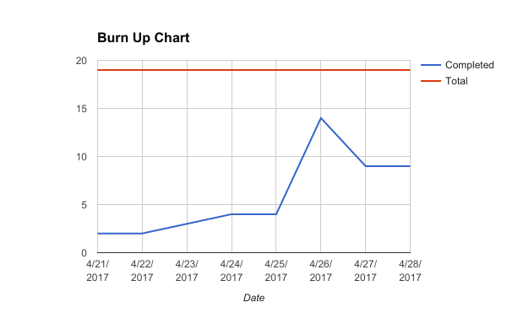

Scrum Board 4/21

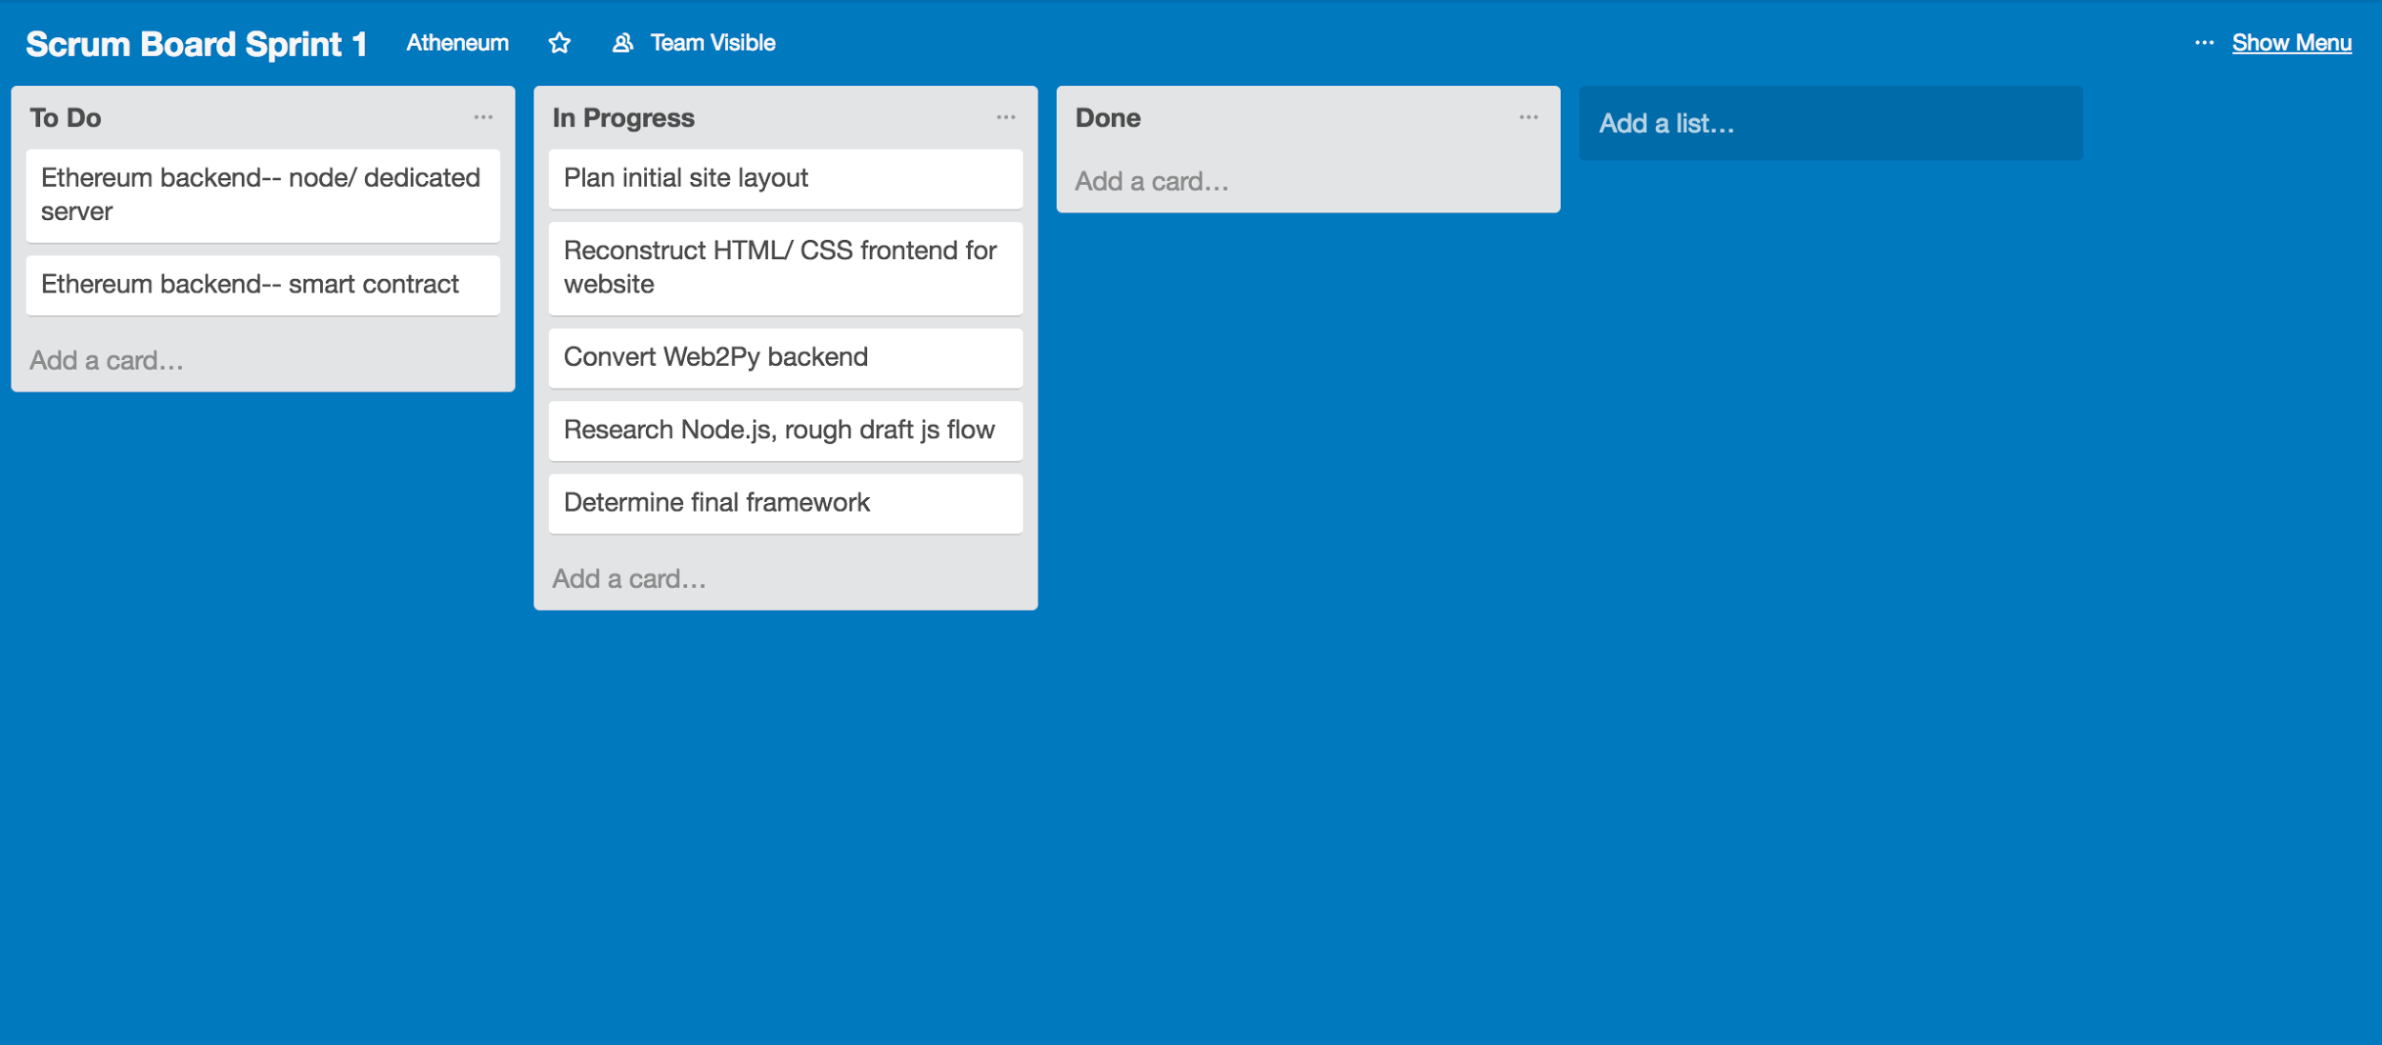

Scrum Board 4/24

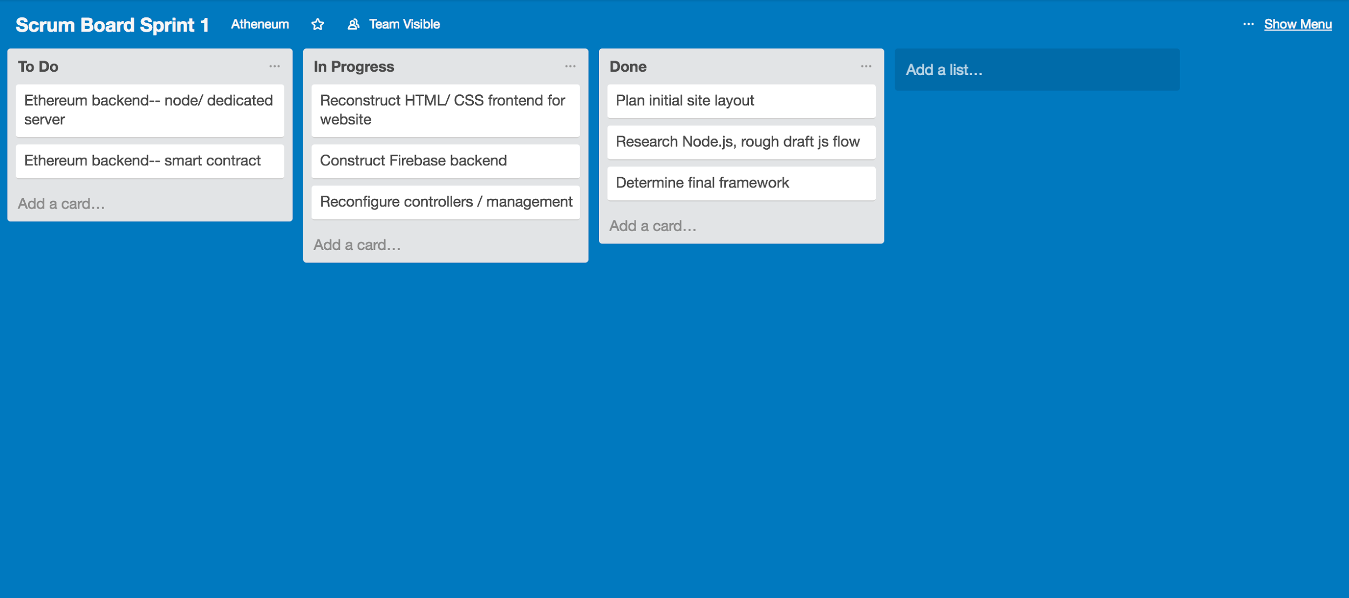

Scrum Board 4/26

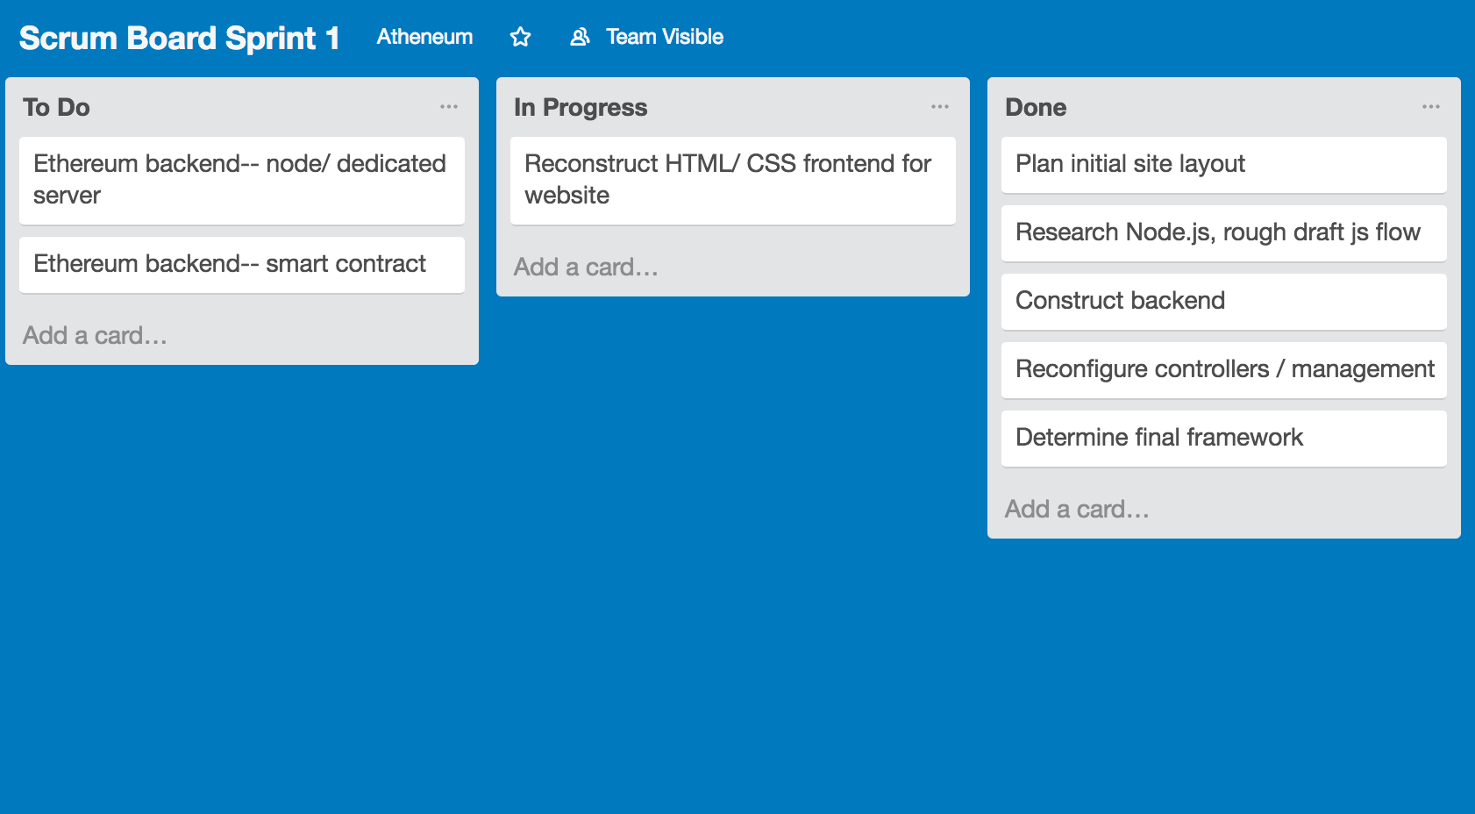

Scrum Board 4/28

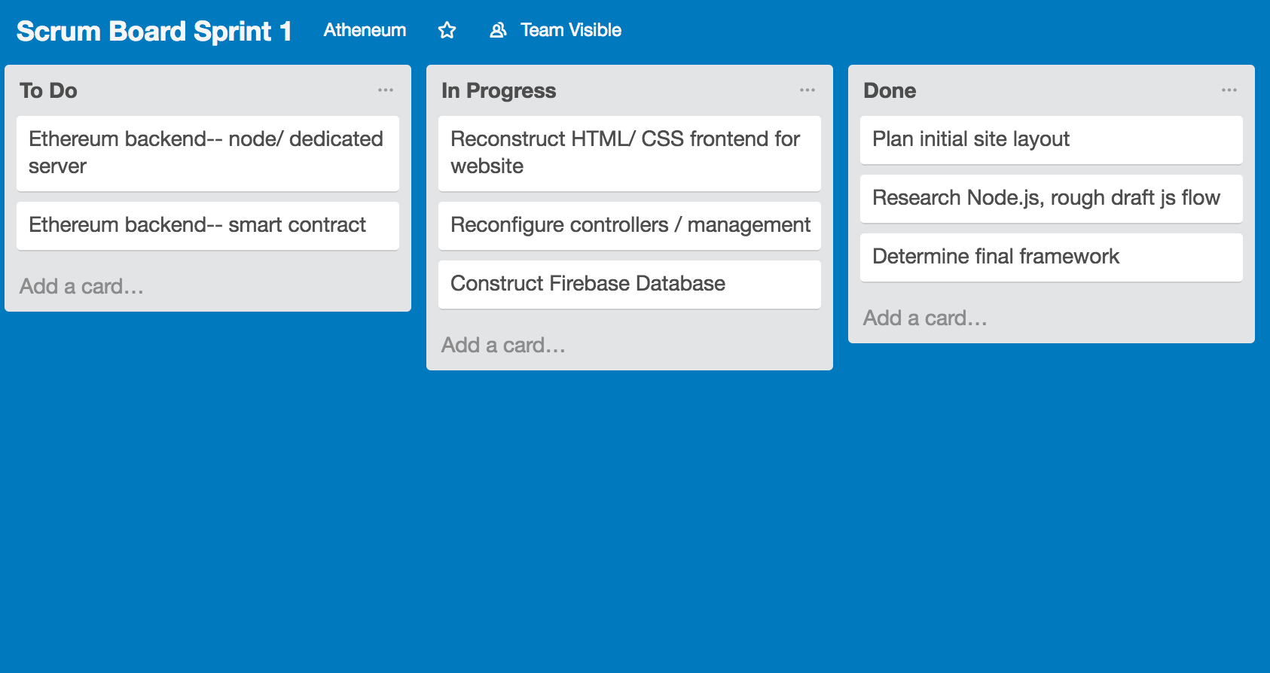

Notes:

After our standup on 4/26, our website’s files in web2py were inadvertently corrupted and since it was the first commit, all files were lost. Thankfully, after this it was decided we would move to using firebase and node.js, so although our first product iteration fell flat it should not affect our next iteration. After discussing what led to this issue, we agreed to commit code more promptly and more often in future sprints.